

SOFTWARE DESIGN SPECIFICATION
Project Name (Code)

– Hanoi, Sep 2025 –

Table of Contents
I. Record of Changes 3
II. Software Design Document 4
1. High Level Design 4
1.1 Software Architecture 4
1.2 Package Diagram 4
1.3 Database Design 5
2. State Transition Diagrams 7
2.1 PIN Validation 7
2.2 … 7
3. Detailed Design 8
3.1 <Feature/Function Name1> 8
3.2 <Feature/Function Name2> 9

I. Record of Changes
Date | A*  M, D | In charge | Change Description
*A - Added M - Modified D - Deleted

II. Software Design Document

1. High Level Design

1.1 Software Architecture
[The content of this section includes the overall architectural diagram which includes the sub-systems and/or components, the external systems (if any), and the relationships (communication messages) among them. You need also provide the explanation for each of the diagram components (modules, sub-systems, external systems, etc.)].
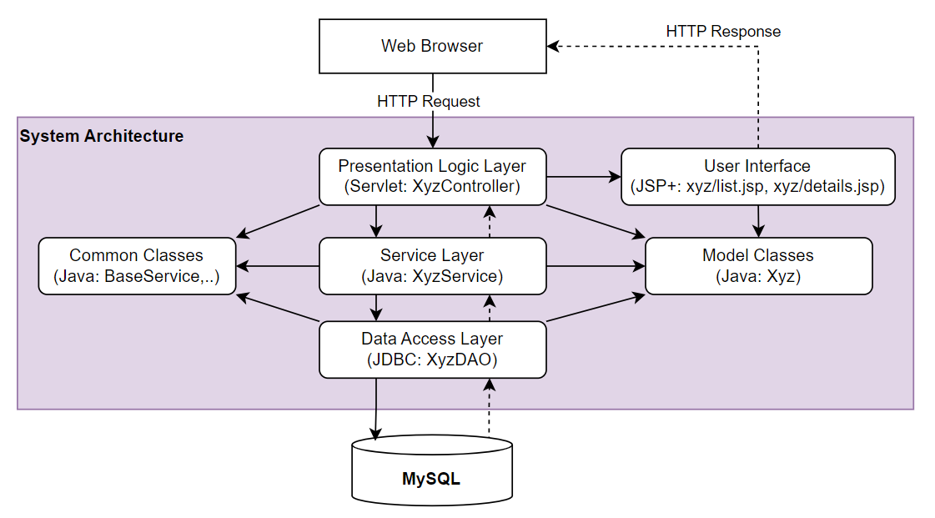-

1.2 Package Diagram
[Provide the package diagram for each sub-system. The content of this section including the overall package diagram, the explanation, package and class naming conventions in each package. Please see the sample & description table format below]
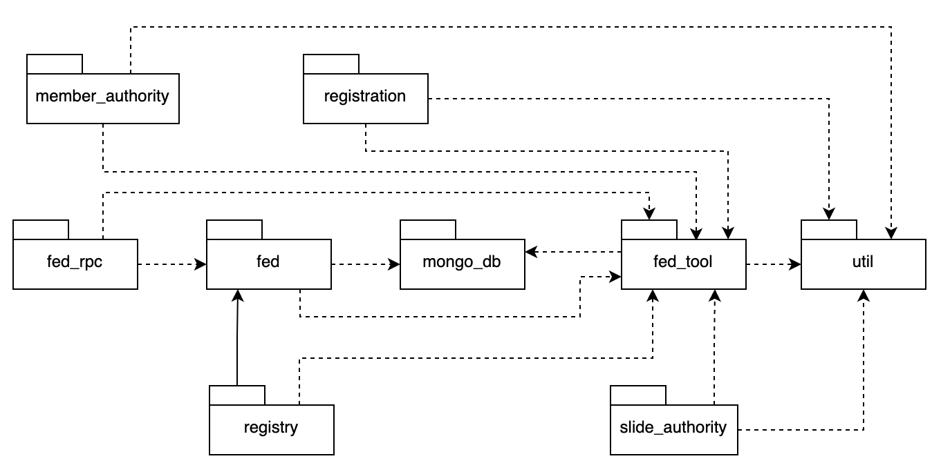
Package descriptions
No | Package | Description
01 | Member_authority | <Description of the package>
02 | registration | <Description of the package>
03 | …

1.3 Database Design
[Provide the files description, database table relationship & table descriptions like example below]

1.3.1 table_name1
[Provide brief description of the table here]
[Provide the detailed table fields description using below table format
* PK~Primary Key; FK~Foreign Key; UN~Unique; NN ~ not null
No | Field | PK | FK | UN | NN | Description
01 | <field_name1> |  |  |  |  | <Description of the field_name1>
02 | <field_name2> |  |  |  |  | …
..

1.3.2 table_name2
…

2. State Transition Diagrams
[Specify and draw state charts (state transition diagrams) for the data and system like below sample. In the diagrams, beside the states, you are required to provide suitable events, actions on the state transitions, entry actions, or exit actions]

2.1 PIN Validation
[Provide state chart with extra explanations if needed]
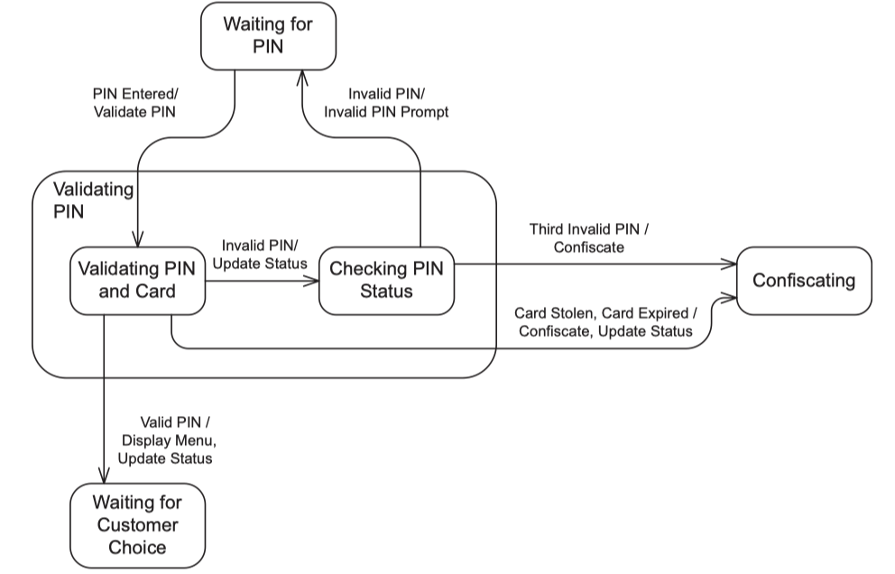

2.2 …

3. Detailed Design

3.1 <Feature/Function Name1>
[Provide the detailed design for the feature <Feature Name1>. It includes Class Diagram and Sequence Diagram(s); For the features/functions with the same structure of class & sequence diagrams, you need to provide the diagrams once for one feature/function and refer to those diagrams from other features/functions]

3.1.1 Class Diagram
[This part presents the class diagram for the relevant feature]
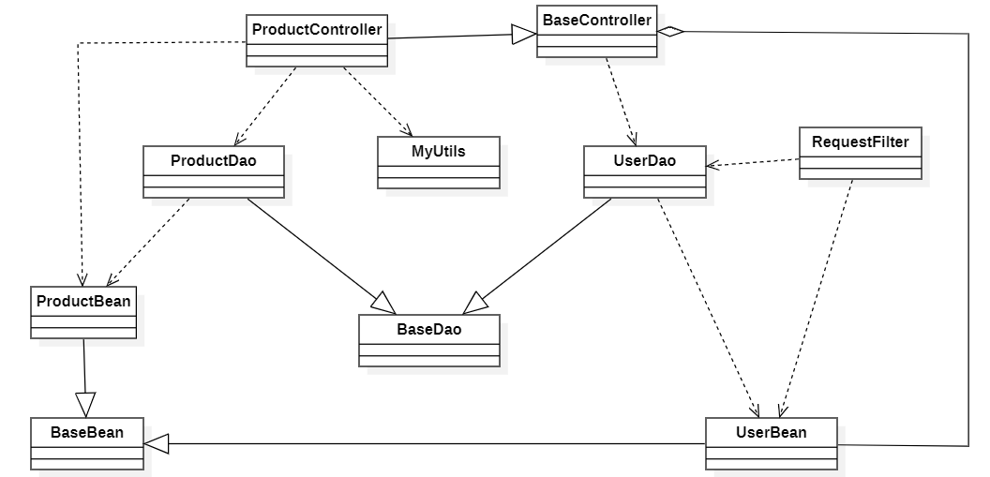

3.1.2 <Sequence Diagram Name1>
[Provide the sequence diagram(s) for the feature, see the sample below]
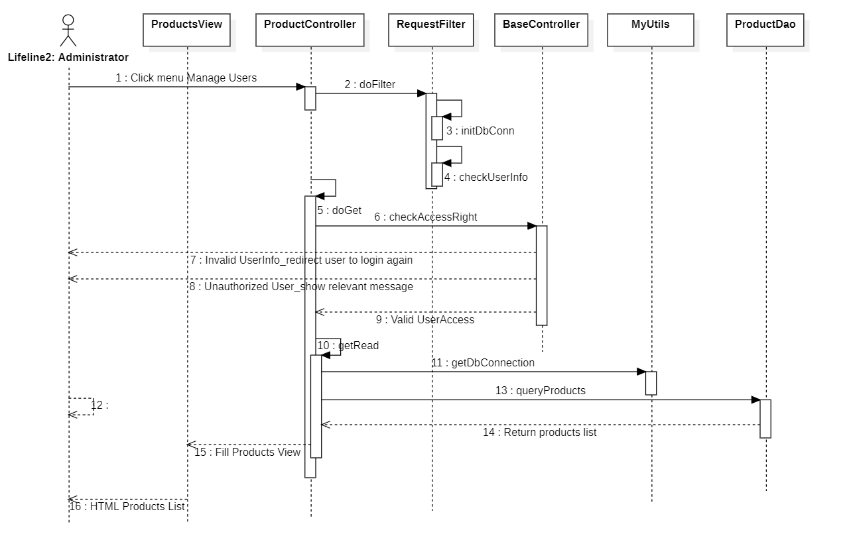

3.1.3 <Sequence Diagram Name2>

3.1.4 …

3.2 <Feature/Function Name2>
…

